Ideation Phase
Brainstorm & Feature Prioritization Matrix (Value vs. Complexity)
Date | 08 October 2026
Team ID | SWUID2026235621
Project Name | iMovies - Cinema Booking Platform
Maximum Marks | 4 Marks

Brainstorm & Idea Prioritization Template:
During our project ideation sessions for iMovies, I facilitated collaborative brainstorming to explore innovative cinema ticketing concepts. We focused on eliminating common moviegoer pain points—such as ticket scalping, checkout seat timeouts, and uninspired movie discovery—by prioritizing ideas based on technical feasibility and direct user value.
I structured our brainstorming and prioritization across four core steps: selecting the problem statement, generating and clustering features (live seat locking, AI movie oracle, multi-city discovery), evaluating ideas on a Value vs. Effort matrix, and charting our final MVP execution roadmap.
Reference: https://www.mural.co/templates/brainstorm-and-idea-prioritization
Step-1: Team Gathering, Collaboration and Select the Problem Statement (Cinema Booking Collision & Discovery Friction)

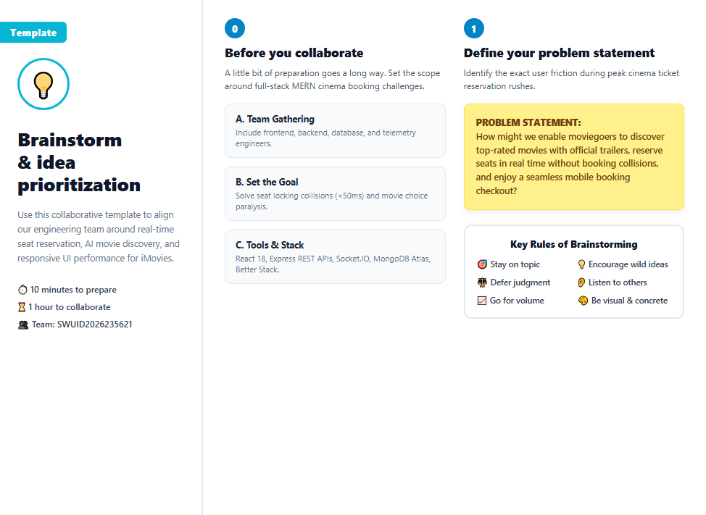

Step-2: Brainstorm, Feature Listing & Clustering (WebSockets, AI Recommendations, Better Stack)
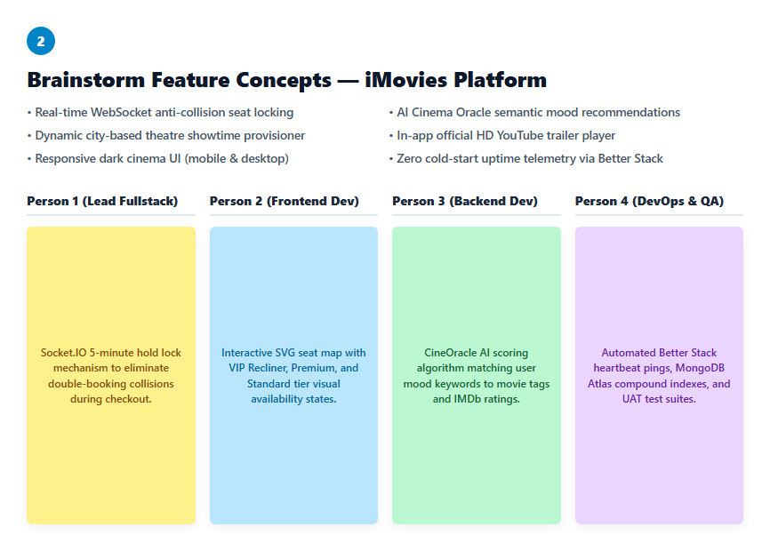
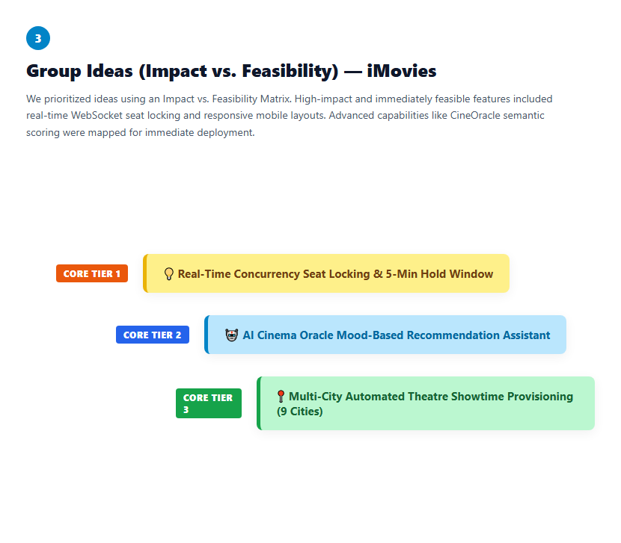

Step-3: Idea Prioritization
